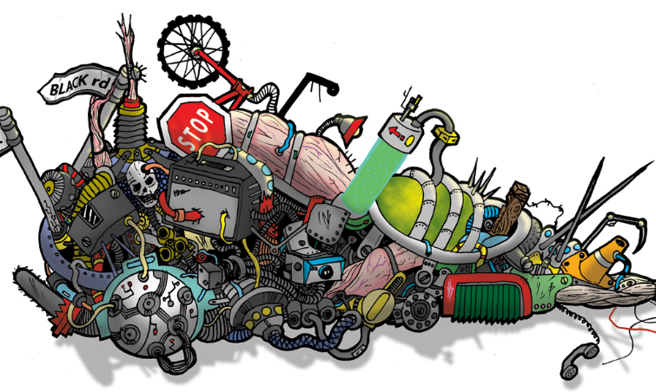
West Valley Fair Bucket of Junk Contest
The objective of a “Bucket of Junk” is to create a sculpture using only the items in the bucket. A sculpture is defined as a three-dimensional work of art that can be viewed from 365 degrees.
Five-gallon buckets of junk will be given to 15 entries on a first-come first-served basis. All 15 buckets will include the same number of items, with unique pieces, otherwise known as junk. Participants may clean, sand, weld, glue, cut, bolt, fasten, bend, shape, paint or finish the items that are provided. No pieces may be added, and one item can be left out. The object is to use all the pieces to create a work of art. There will be a list of contents in each bucket. All sculptures must be presentation-ready when submitted. Projects may be mounted to a solid base for stability if needed. Please return your empty bucket and list of contents.
Please reserve your bucket by calling or texting Kattie Blanchard at 509-945-9309
Buckets may be picked up Saturday May 13th or Saturday June 10th at the work day events. Any unreserved buckets will be available on a first come first served basis.
Entries are due Saturday July 15th from 9am-4pm

JUDGING CRITERIA: Contestant used only the materials that were provided (required)
25% Contestant used the materials in a new way to create something different.
25% Contestant’s ideas are recognizable. (Clarity of the idea)
25% Contestant’s overall finished appearance of the sculpture
25% This includes the difficulty of the piece and how well it was made
Judging Categories Youth Ages 5-7, 8-10, 11-13, 14-18

